|  |  |  |
| --- | --- | --- |
|  | CSBE_logo_BW |  |
| **The Canadian Society for Bioengineering** *The Canadian society for engineering in agricultural, food, environmental, and biological systems.* | **La Société Canadienne de Génie Agroalimentaire et de Bioingénierie**  *La société canadienne de génie agroalimentaire, de la bioingénierie et de l’environnement* |

Paper No. CSBE18-XXX

Paper Title

Author#1

Contact Information

Author#2

Contact Information

Written for presentation at the

CSBE/SCGAB 2018 Annual Conference

University of Guelph, Guelph, ON

22-25 July 2018

Abstract Type your abstract here, after the word "Abstract" starting on the same line. Many readers will see only the abstract, so include your major findings in a useful and concise manner. Include a problem statement, objectives, brief methods, quantitative results, and the significance of your findings. The abstract should be no more than 250 words long.

Keywords: Leave the word "Keywords" then type specific or general keywords or key phrases, separated by commas.

Introduction Write your introduction in “Normal” style after the word INTRODUCTION. Hit ENTER only once to begin a new paragraph. Do not indent or justify the text, this will be done automatically by the style sheet.

Main sections here after start with heading 1 Paragraphs are all in "Normal" style and start on the same line as the heading. Write your heading and text continuously in Normal style and then, select your heading and apply the proper heading style.

Subsections start with Heading 2 Write your text here.

Subsections start with Heading 3 Write your text here. You must not exceed three levels of headings.

Use a "List Start" paragraph before a list. This looks like a normal paragraph, but is used in the software to make a list come next.

* **Uniformity.** The template helps provide a uniform appearance for all papers by controlling formatting details such as margins, font selection, indenting, and spacing.
* **Pagination.** A page number is automatically added in the footer of each page.
* **Proofreading.** Be sure to have someone proofread your paper. It will not be proofread by the CSBE scientific committee.
* **Posters.** This template is for the written paper, NOT for the poster presentation. Text for a poster presentation should be considerably larger and positioned for good appearance at a distance of 2 m.
* **Citations.** Cite each of your references in the text, either parenthetically (Author et al., 1998) or as part of a sentence, e.g., Bookauthor (1993) stated that…. Do not use footnotes. Please do not use hyperlinks; web addresses (URLs) that are not live hyperlinks are OK.
* **Units.** Use SI units.
* **Figures.** Figures should be inserted within your text. Please have figures sized appropriately: Do not exceed page margin and set the resolution to a maximum of 200 dpi. Insert good quality figures and images. Tip: after importing you jpg, png or gif image in your paper, apply the compression tool 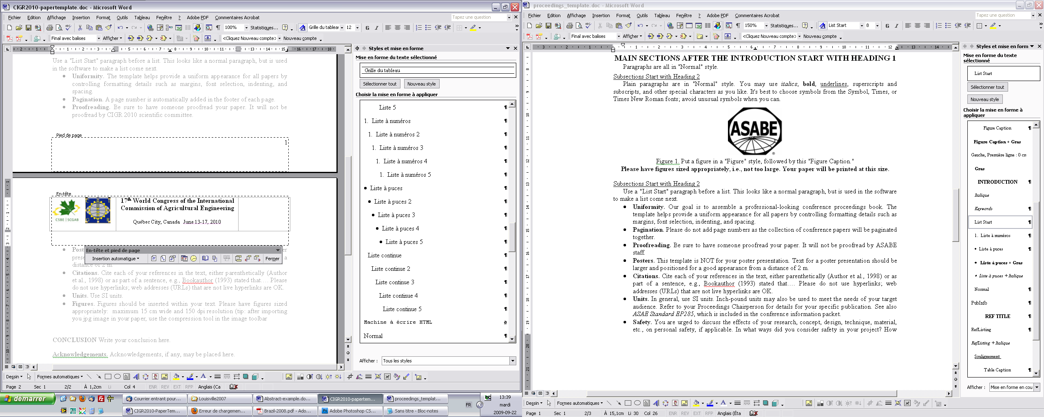 in the image toolbar; this will reduce the overall file size. Your images can contain color but you should use a graphical code rather than a color code in your chart or plot for grey scale printing.
* **Tables.** Data in tables must not be linked to a MS Excel file. Make sure that only values are reported in your text and format your table following the model below. You could use 10 or 12 pt font size. Your table should not exceed margins.

Figure, table and equation examples:



Figure 1. Maximum, final mean MC and MC standard deviation of the optimized drying scenarios at initial MC of 0.25, 0.35 and 0.45 d.b.

Here is an equation:  (1)

Table 1. Specifications of four experimental drying runs used for validation.

|  |  |  |  |  |  |
| --- | --- | --- | --- | --- | --- |
| Run | Initial drying air conditions | | Air velocity | Hay density | Drying time |
|  | Temperature | Relative humidity |  |  |  |
|  | (°C) | (%) | (m/s) | (kg DM/m³) | (min) |
| 1 | 29.3 | 31.6 | 0.20 | 221 | 1020 |
| 2 | 44.7 | 20.1 | 0.20 | 227 | 540 |
| 3 | 60.0 | 9.3 | 0.29 | 104 | 300 |
| 4 | 60.0 | 8.1 | 0.26 | 107 | 420 |

Conclusion Write your conclusion here. Remove all unnecessary text (such as these instructions). The total length of the paper, including appendices should not be more than ten (10) pages.

**Acknowledgements.** Acknowledgements, if any, may be placed here.

References

ASAE Standards, 36th ed. 1989. S352.1: Moisture measurement -- Grain and seeds. St. Joseph, Mich.: ASAE.

Coombs, T. R., and F. C. Watson. 1997. Computational Fluid Dynamics. 3rd ed. Wageningen, The Netherlands: Elsevier Science.

NSC. 2001. Injury Facts Online. Itasca, Ill.: National Safety Council. Available at: www.nsc.org. Accessed 17 December 2001.

Waladi, W., B. Partek, and J. Manoosh. 1999. Regulating ammonia concentration in swine housing: Part II. Application examples. Trans. ASAE 43(4): 540-547.

Appendix A

Additional information, tables, and/or figures may be appended here, after your references.